**TDS - Temperature Calculation using temperature ADC**

The specific temperatures has been determined based on the **ADC versus Set temperature**  (Refer file ADC Vs Set Temperature.xlsx).

With respect to Linear Equation of **ADC (X) Vs Set Temperature (Y) of Slave 1**:

**Y = ( -0.0904 (X) ) + 71.219**

Y = Set temperature

X = Avg Adc

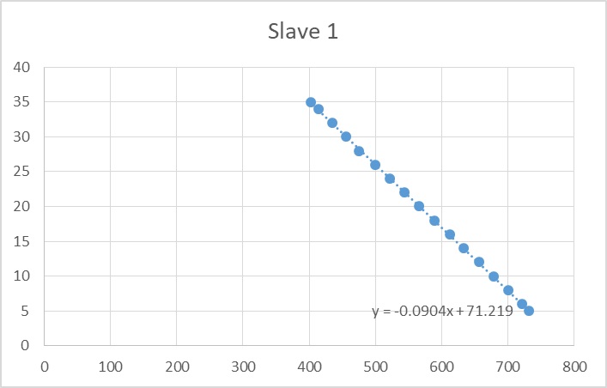

**Calculating Temperature after Calibration**:

**Calibrated Temperature Value = ( -0.0904 * (Temperature Adc) ) + 71.219**

**Temperature Calculation For Each Slaves:**

The Offset value at specific Temperatures for each Slaves has been determined based on the **Error rate versus Set temperature** (Refer file *ADC Vs Set Temperature.xlsx*)

**Linear Equations of Tempeach Slaves based on :**

Slave 1: y = -0.0904x + 71.219

Slave 2: y = -0.0906x + 71.686

Slave 3: y = -0.0902x + 71.038

Slave 4: y = -0.0909x + 71.862

Slave 5: y = -0.0898x + 70.741

Slave 6: y = -0.0899x + 70.99

Slave 7: y = -0.09x + 71.04

Slave 8: y = -0.0895x + 70.728

Slave 9: y = -0.0902x + 71.244

Slave 10: y = -0.0905x + 71.388

Slave 11: y = -0.0902x + 71.209

Slave 12: y = -0.0902x + 71.148

Slave 13: y = -0.0905x + 71.301

Slave 14: y = -0.0899x + 71.106

Slave 15: y = -0.0898x + 71.008

Slave 16: y = -0.0902x + 71.141

Slave 17: y = -0.0902x + 70.92

Slave 18: y = -0.0902x + 71.08

Slave 19: y = -0.0903x + 71.161

Slave 20: y = -0.0904x + 71.381

Slave 21: y = -0.0902x + 71.078

Slave 22: y = -0.0902x + 71.179

Slave 23: y = -0.0903x + 71.04

Slave 24: y = -0.0904x + 71.234

Slave 25: y = -0.0904x + 71.103

**Examples:**

**Y = Temperature**

**X = ADC value in mV**

Slave 1: y = -0.0904 * 400 + 71.219 = 34.8196

Slave 2: y = -0.0906 * 500 + 71.686 = 22.686

Slave 3: y = -0.0902 * 600 + 71.038 = 16.638

Slave 8: y = -0.0895 * 450 + 70.728 = 30.675

Slave 9: y = -0.0902 * 550 + 71.244 = 20.744

Slave 10: y = -0.0905 * 650 + 71.388 = 10.638

Slave 11: y = -0.0902 * 475 + 71.209 = 27.2894

Slave 12: y = -0.0902 * 525 + 71.148 = 23.7996

Slave 13: y = -0.0905 * 575 + 71.301 = 20.1987

Slave 14: y = -0.0899 * 625 + 71.106 = 10.7311

Slave 19: y = -0.0903 * 450 + 71.161 = 30.9797

Slave 20: y = -0.0904 * 500 + 71.381 = 22.7816

Slave 24: y = -0.0904 * 550 + 71.234 = 17.6144

Slave 25: y = -0.0904 * 600 + 71.103 = 12.1036